**Database Project 1**

Sam is a movie store owner. He currently manages his tock manually.

Sam owns a computer in his store for the sole purpose to play music and watch movies.

Sam is faced with a problem in his business. Clients are not sure of what movie title to buy or rent but would rather ask for a genre, year of release or the most trending movie etc.. You guessed right! Sam is having hard time satisfying his customers.

As a database designer/developer would you assist Sam do the following:

1. Create a database and name it STORE

2. Create a table inside the database and name it MOVIES.

3. The table must contain the following columns :

a. Movie ID

b. Movie title

c. Movie released year

d. Movie length (time in minute)

e. Movie language

4. Create a script to add the following data inside the table the table:

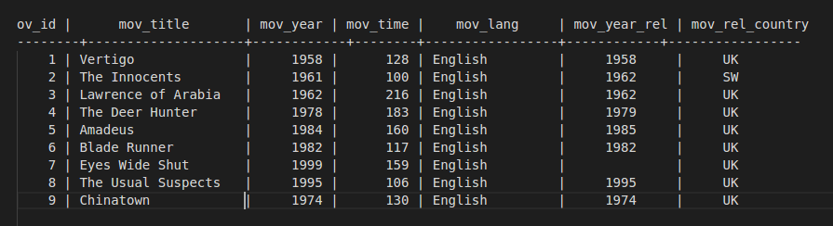

5. create a script to view all movies

6. Sam would like to update the release year of a movie titled '**Eyes Wide Shut to 1999**’. create a script that will update the movie.

7. A movie titled '**Vertigo**' is no more in store. Create a script that will remove the movie details from the table.

**Submission instructions**

1. Create scripts from 1 to 4 then store them in a file named database.sql.
2. Run each script on your computer using [Mysql](https://umuzi.gnomio.com/mod/book/view.php?id=161&chapterid=106). Ensure that each script works smoothly.
3. Make sure each script is titled and explained.

i.e. 2. Create a table inside the database and name it MOVIES.

--------- script here --------

1. Upload the file to github
2. share the link to your repo [here](https://docs.google.com/spreadsheets/d/1VZSmMuDHMsbJg3SAc0JRYkrtTMl0Rvt6cVb8JAONnVw/edit#gid=0).